Updated Draft Preliminary Flood Risk Assessment
for
the Danube River Basin Management District

Executive Summary

March 2021

This updated draft Preliminary Flood Risk Assessment for the the Danube River Basin Management District has been prepared with the financial support of the Cohesion Fund of the European Union, through Operational Program "Environment 2014-2020", under a Priority Axis 4 “Flood and Landslides Risk Prevention and Management” procedure for direct grant BG16M1OP002-4.005 “Implementation of studies and assessments in relation to the second FRMP for the period 2022-2027” for the project: BG16M1OP002-4.005-0001 „FRMP – second cycle 2022-2027”. Project beneficiary is the Water Management Directorate, in partnership with the four River Basin Directorates.This activity has been carried out by the International Bank for Reconstruction and Development under an Agreement with the Ministry of Environment and Waters on providing support for the development of RBMPs and FRMPs for Bulgaria.

The current document provides an executive summary of the updated Preliminary Flood Risk Assessment (PFRA) for the Danube River Basin Management District. PFRA is an initial stage of the implementation process of Directive 2007/60/EC (European Floods Directive, FD). As per the requirements of FD Chapter VI, Member States shall review and if necessary, update the PFRA every six years.
- Legal Basis, Objectives and Scope
Directive 2007/60 / ЕС (Floods Directive or FD) has been in force since November 26, 2007. In the legislation of the Republic of Bulgaria it has been transposed with the amendment of the Water Act (WA) in 2010, SG No. 61/2010).
The purpose of the FD is to establish a framework for flood risk assessment and management, aiming to reduce the adverse effects on human health, economic activity, the environment and the cultural heritage associated with floods and thus to have a positive impact on flood risk management at a Member State level as well as in international river basins.
The FD requires Member States to apply a long-term planning approach to flood risk mitigation at national level in three successive stages:
- Preparation of Preliminary Flood Risk Assessment (PFRA) and identification of areas with a significant potential risk of floods (APSFR);
- Development of flood hazard and risk maps for the identified flood risk areas (mapping);
- Development of Flood Risk Management Plans (FRMPs), including Programme of measures to achieve the objectives of flood risk management.
The requirements regarding the content of the PFRA are set out in Section II “Preliminary Flood Risk Assessment” of Chapter Nine of the WA.

PFRA OBJECTIVES

PFRA aims to provide a quick overview of flood hazard and flood risk across the country, identifying areas where hazard and risk levels are higher based on certain criteria.
Analyzes must be based on available or readily accessible information on both hazard and risk, whereas climate change and its impacts on flood hazard and risk must also be taken into account.

The ultimate objective of the PFRA is to identify Areas of Potential Significant Flood Risk (APSFRs) where there is:
- Potential significant flood risk;
- Likelihood for potential significant flood risk.
PFRA SCOPE

- River basin maps indicating topography and land-use;
- Description of past floods with significant adverse effects on human health, the environment, cultural heritage and economic activity;
- Identifying areas with potential flood hazard of 1% exceedance probability;
- Determining potential damages in areas with potential hazard depending on land-use type;
- Assessing possible adverse effects of future floods on human health, the environment, cultural heritage and economic activities;
- Flood risk assessment by applying significance criteria of potential damages and identifying areas with significant flood risk.
- Informing the public.
FD activities, incl. PFRA are reviewed and updated, if necessary, every six years.

- PFRA Methodology
The Preliminary Flood Risk Assessment is carried out in accordance with the adopted “2020 Preliminary Flood Risk Assessment Methodology” (hereinafter the Methodology). The PFRA Methodology is available on the MOEW website under: https://www.moew.government.bg/static/media/ups/tiny/filebase/Water/PURN/PURN%202022-2027/Metodika.pdf
The Methodology consists of two main parts:
- Preliminary Flood Risk Assessment under FD Art. 4;
- Areas of Potential Significant Flood Risk under FD Art. 5.

The Methodology determines the algorithm and necessary approach to implement each of the analyzes used for the preparation of the Danube RBD PFRA.

- Danube RBMD PFRA Content
The draft Preliminary Flood Risk Assessment prepared for the Danube River Basin Management District (RBMD) observes the “2020 Preliminary Flood Risk Assessment Methodology”. It has been developed as a single document with respective Appendixes, as presented in the diagram below.

- Characteristics of the Danube River Basin Management District
The Danube River Basin Management District covers the northern part of the Republic of Bulgaria. It includes all river valleys with direct inflow to the Danube. The district’s area is 47,234.7 sq.km or 42.6% of the country’s territory.
Danube RBMD
East Aegean RBMD
Black Sea RBMD
West Aegean RBMD
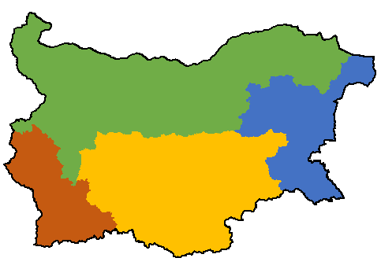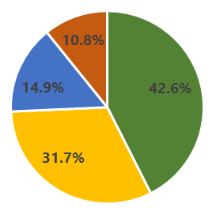

The Danube RBMD includes 17 river valleys located entirely within the district (incl. Kanagyol and Suha Reka rivers) and 3 transboundary river valleys - those of the Danube, Nishava and Timok rivers.

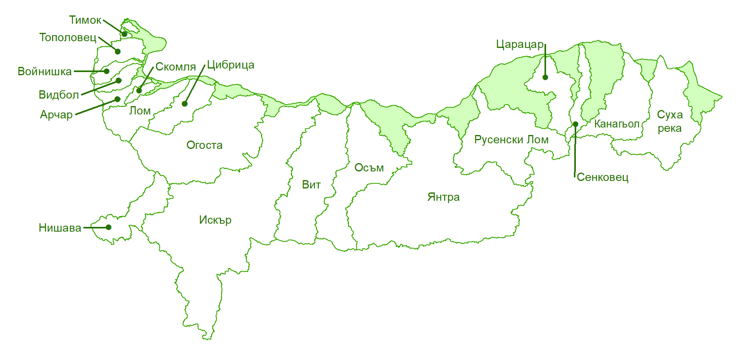

There are 18 administrative districts, 126 municipalities and 2261 settlements within the RBMD’s territorial scope.

- Climate Change Assessment
Climate change has been assessed within the updated PFRA based on two types of input data for four main flood-related parameters. The respective changes have been assessed for 3 time periods and two Intergovernmental Panel on Climate Change (IPCC) scenarios, as shown in the following diagram:

Input data
Investigated parameters
Analyzed periods
The PFRA has been carried out using data from the CORDEX project (Coordinated Regional Climate Downscaling Experiment) and in particular, its MED-CORDEX subproject - specially developed for the Mediterranean by the National Center for Meteorological Research - France (CNRM, Météo-France).
With regard to atmospheric or oceanic long-period fluctuations, a total of 7 indices of atmospheric or oceanic long-period fluctuations have been considered. Climate data series from ground-based stations of the Bulgarian national meteorological network are limited, both in terms of their quantity and data access, and in some cases there is no metadata on their accuracy. Hence, 24-hour precipitation data from the regional reanalysis MESCAN-SURFEX - a Copernicus Climate Change Service (C3S) product, have been used as historical data.
Schematic maps of the most significant projected changes have been prepared for each of the investigated precipitation indicators for the three periods 2031-2060, 2051-2080 and 2071-2100, as compared to the reference period 1961-2017. These schematic maps present the data under two IPCC RCP scenarios (RCP4.5 and RCP8.5). Below figure shows a schematic map for the period 2051-2080 under the RCP4.5 scenario.
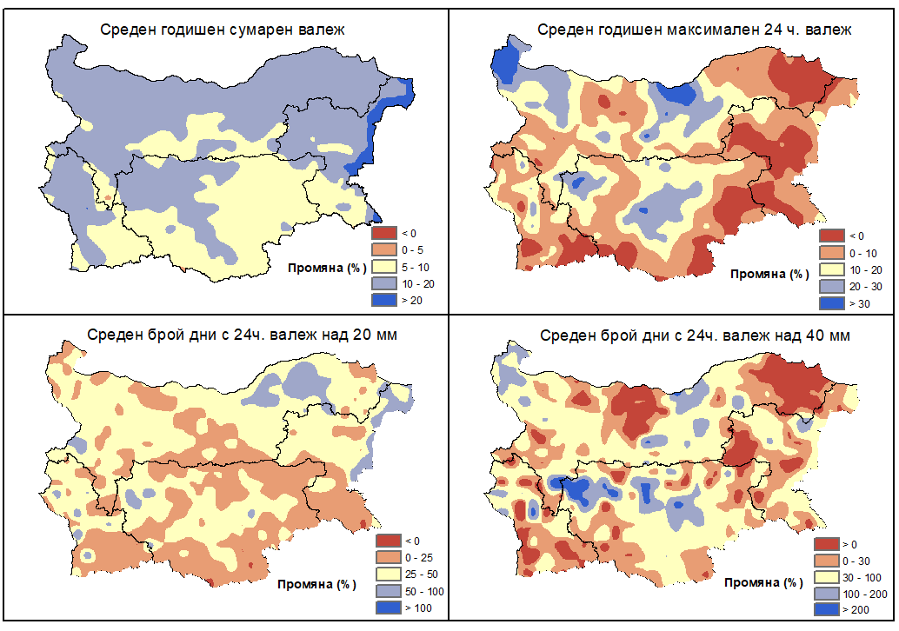
Climate change analysis results have been used to:
- Determine and investigate areas of future floods;
- Identify APSFRs;
- Create APSFR passports.

- Information Used for the Preparation of PFRA
PFRA requires carrying out a number of analyzes on flood hazard and risk covering the entire Danube RBMD territory. On the other hand, the need to compare results between the country’s different river basin management districts mandates that the input data used should be readily available and easily accessible at national level, as well as standardized and of the same quality and detail.
The following types of data have been used to perform the PFRA:

- Past Floods

  - Past floods registered in the period 2011-2019.
217 floods were registered on the territory of the Danube RBMD between 2011 and 2019, which occurred in 341 locations (settlements).
Pluvial floods have the largest relative share, as well as mixed fluvial-pluvial floods. Fluvial floods come second in terms of relative share, whereas infrastructure-related flooding and floods caused by groundwater have the smallest share.

  Fluvial floods |   Pluvial floods |   Flooding from groundwater |   Infrastructure-related flooding
The distribution of flooding instances per year shows a trend of less occurrences in the period 2011-2013 and a clear peak in 2014 (38% of all registered floods), followed by a drastic drop and gradually increasing trend between 2015-2019.

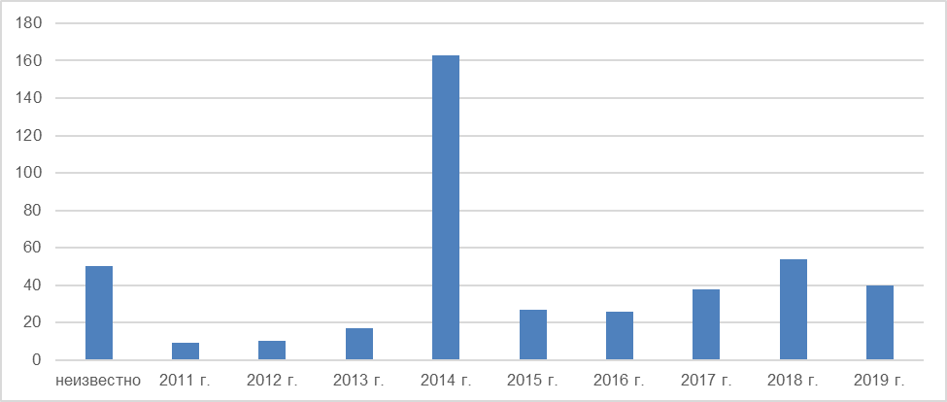

2011
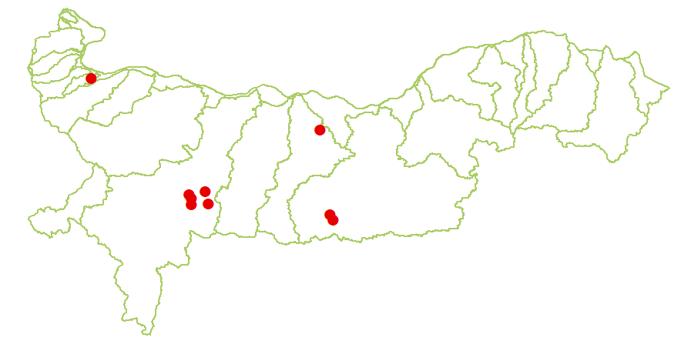Number of registered floods is small. In almost 90% of cases they resulted from rainfall.
Floods occurred in the Iskar catchment area (its right tributary - the Malak Iskar river), in the lower Osam river and in the Yantra river valley (the upstream section of Rositsa river).
Floods were registered during the year’s spring-summer period - end of June and beginning of August.
Described adverse effects are under the category Economic Activity, specifically damages to infrastructure sites.
Types of floods
Number of floods per type in relation to total number
  Fluvial floods |   Pluvial floods |   Flooding from groundwater |   Infrastructure-related flooding
Adverse effects
Types of described adverse effects per category in relation to total number of floods
  Human Health |   Economic Activity | Environment |   Cultural Heritage

2012
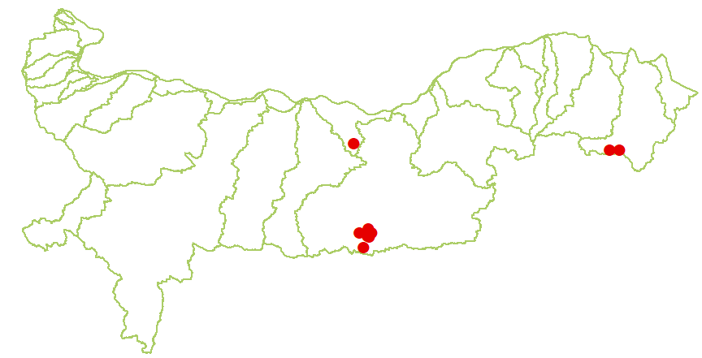Number of registered floods is small. All occurrences resulted from rainfall, and in some cases they are combined with infrastructure-related flooding.
Floods occurred mainly in the upstream section of Yantra river (near the town of Gabrovo) and the upstream section of Suha Reka river (near the town of Valchi Dol).
Floods were registered in the middle of May.
Described adverse effects again fall under the category Economic Activity - damages to real estate and infrastructure sites. Impacts on human health and disruption of access to public services were registered to a lesser extent. The environmental consequences were related to disturbances in water body status and flooded agricultural lands.
Types of floods
Number of floods per type in relation to total number
  Fluvial floods |   Pluvial floods |   Flooding from groundwater |   Infrastructure-related flooding
Adverse effects
Types of described adverse effects per category in relation to total number of floods
  Human Health |   Economic Activity |   Environment |   Cultural Heritage

2013
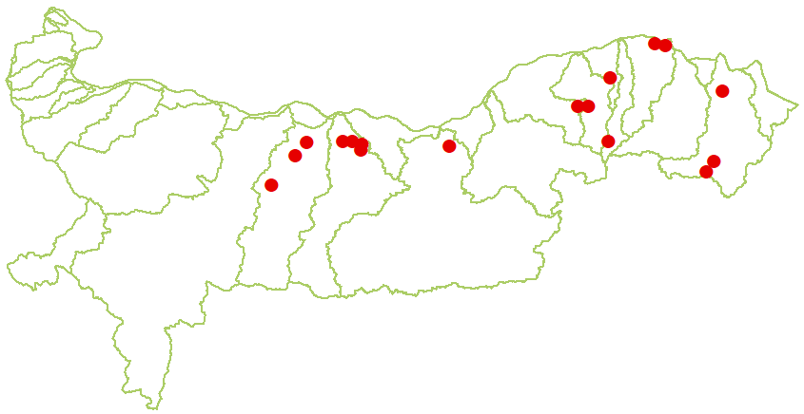Number of registered floods is small, however, with an increasing trend. About 95% of all occurrences are pluvial floods.
They occurred in the downstream sections of Vit, Osam and Yantra rivers and east of them, in the Suha Reka river valley and in some places in Dobrudzha.
Floods were registered during the year’s spring-summer period - end of May, the entire month of June and beginning of July.
Described adverse effects again fall under the category Economic Activity - damages to real estate and infrastructure sites. Impacts related to human health and disruption of access to public services were registered to a lesser extent.
Types of floods
Number of floods per type in relation to total number
  Fluvial floods |   Pluvial floods | Flooding from groundwater | Infrastructure-related flooding
Adverse effects
Types of described adverse effects per category in relation to total number of floods
  Human Health |   Economic Activity | Environment | Cultural Heritage

2014
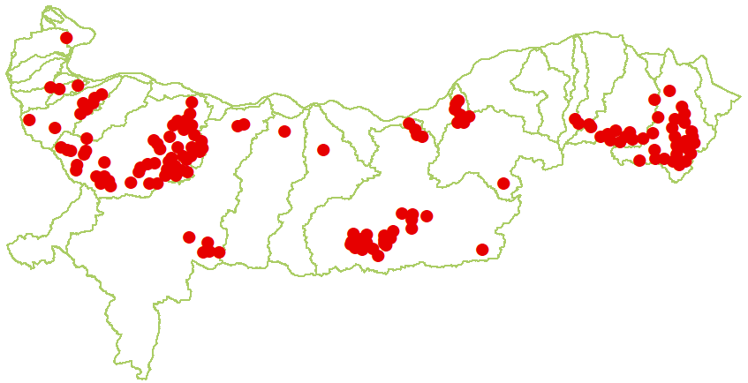The number of registered floods in 2014 is the highest for the entire reviewed period (2011-2019) - a total of 163. In more than 100 cases the sole cause of flooding is rainfall, whereas 80 floods were fluvial in nature.
Floods occurred in 4 main areas: 1. river valleys west of Ogosta river, mostly Ogosta river itself, 2. upper sections of the Yantra catchment area (specifically Lopushnitsa, Yantra and Dryanovska rivers), 3. downstream sections of Yantra river and Rusenski Lom river, 4. the Suha Reka catchment area and upstream sections of Harsovska river.
Flooding occurred throughout the year. A peak in the number of occurrences was observed in June (33% of all floods during the year) and July (40%).
Described adverse effects again fall under the category Economic Activity, with the largest relative share being damages on infrastructure sites, followed by real estate and to a lesser extent on primary and secondary sector activities. The share of registered impacts on human health is significant, in particular with regard to disruption of access to public services and less so in terms of people’s health. The environmental consequences were related mainly to flooded agricultural lands and to a lesser extent disturbances in water body status.
Types of floods
Number of floods per type in relation to total number
  Fluvial floods |   Pluvial floods |   Flooding from groundwater | Infrastructure-related flooding
Adverse effects
Types of described adverse effects per category in relation to total number of floods
  Human Health |   Economic Activity |   Environment | Cultural Heritage

2015
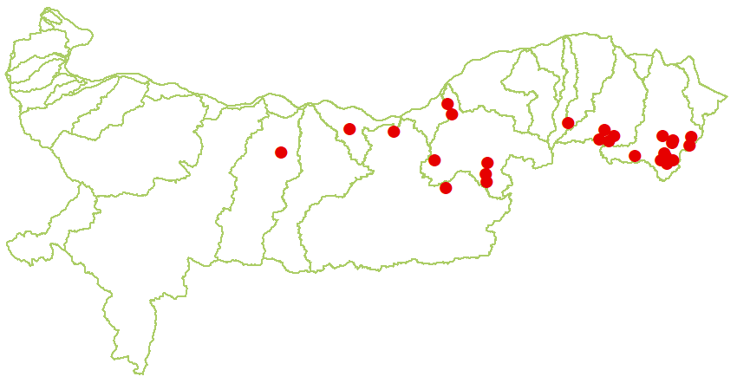The number of registered floods decreased significantly - 27 occurrences in 26 settlements. They were mainly pluvial, however, the number of fluvial floods wasn’t negligible.
Floods affected mainly river valleys in the northeastern part of the RBMD - upstream sections of Suha Reka river, the Harsovska river catchment area and the Rusenski Lom river valley.
Most floods occurred during the winter season - from mid-January to early February.
Described adverse effects again fall under the category Economic Activity - damages on infrastructure sites and to a lesser extent on real estate. Impacts on human health and disruption of access to public services were registered to a lesser extent. The environmental consequences were related mainly to flooded agricultural lands.
Types of floods
Number of floods per type in relation to total number
  Fluvial floods |   Pluvial floods | Flooding from groundwater |   Infrastructure-related flooding
Adverse effects
Types of described adverse effects per category in relation to total number of floods
  Human Health |   Economic Activity |   Environment | Cultural Heritage

2016
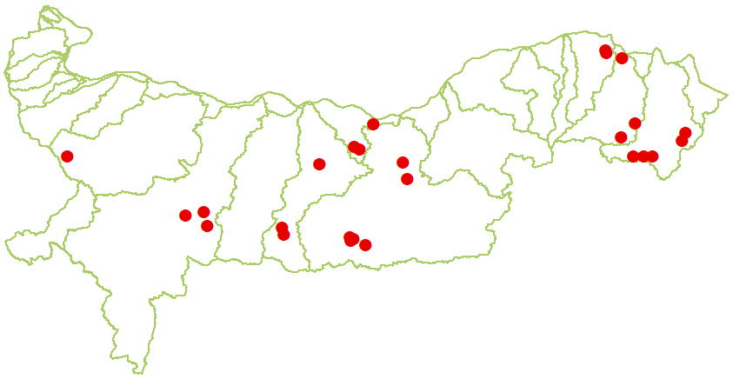The number of registered floods remained almost unchanged compared to the previous year. About 80% of all occurrences were pluvial, whereas the remaining 20% were mixed (pluvial and fluvial).
Floods occured mainly in the Osam, Yantra and Suha Reka river valleys.
Most floods occurred at the end of May and beginning of June.
Described adverse effects again fall under the category Economic Activity - damages on infrastructure sites and to a lesser extent on real estate and primary sector economic activities. Impacts on human health were registered to a lesser extent. The environmental consequences were related mainly to flooded agricultural lands.
Types of floods
Number of floods per type in relation to total number
  Fluvial floods |   Pluvial floods | Flooding from groundwater | Infrastructure-related flooding
Adverse effects
Types of described adverse effects per category in relation to total number of floods
  Human Health |   Economic Activity |   Environment | Cultural Heritage

2017
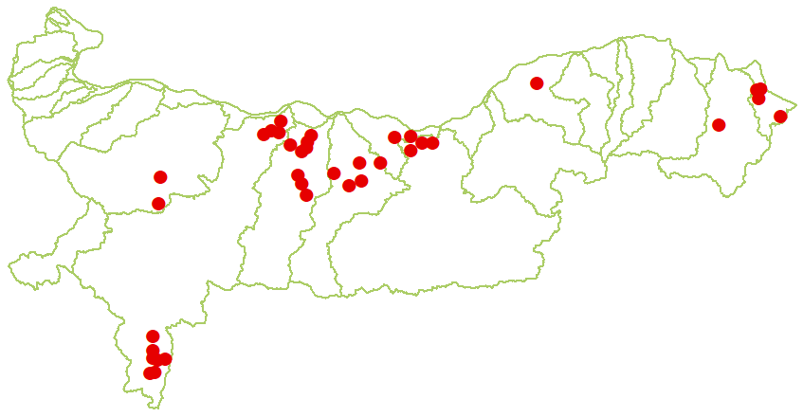The number of registered floods increased compared to the previous year. Over 75% of all occurrences resulted from rainfall, whereas the rest were mixed fluvial-pluvial floods.
Floods occurred mainly in downstream sections of the Iskar, Vit, Osam and Yantra rivers.
They were registered between the beginning of May and beginning of June.
Described adverse effects again fall under the category Economic Activity - damages on infrastructure sites and to a lesser extent on real estate and primary sector economic activities. The share of adverse impacts on human health was not negligible; disruption of access to public services occurred to a lesser extent. The environmental consequences were related mainly to flooded agricultural lands.
Types of floods
Number of floods per type in relation to total number
  Fluvial floods |   Pluvial floods | Flooding from groundwater |   Infrastructure-related flooding
Adverse effects
Types of described adverse effects per category in relation to total number of floods
  Human Health | Economic Activity |   Environment | Cultural Heritage

2018
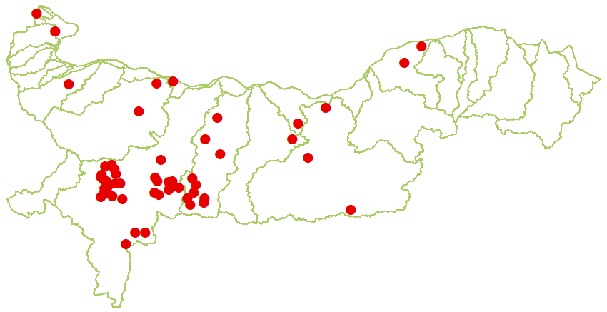The increasing trend of registered floods continued. In terms of origin, there were pluvial, fluvial and mixed pluvial-fluvial floods.
Floods occurred mainly in the middle sections of the Iskar river valley (Iskar river in the Iskar Gorge and Malak Iskar river) and the Vit river valley (mainly upstream).
Floods were registered between the middle of June and the beginning of August.
Described adverse effects again fall under the category Economic Activity - damages on infrastructure sites, real estate and to a lesser extent on primary and secondary sector economic activities. The share of adverse impacts on human health was small. The environmental consequences were related mainly to flooded agricultural lands.
Types of floods
Number of floods per type in relation to total number
  Fluvial floods |   Pluvial floods | Flooding from groundwater |   Infrastructure-related flooding
Adverse effects
Types of described adverse effects per category in relation to total number of floods
  Human Health | Economic Activity | Environment | Cultural Heritage

2019
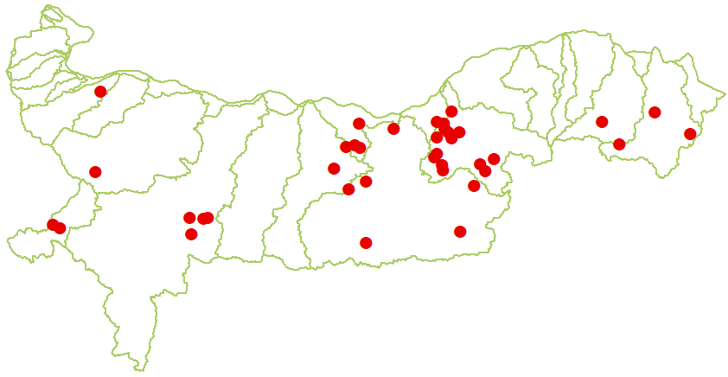The number of registered floods decreased compared to the previous year. In terms of their source, most floods were pluvial and to a lesser extent mixed pluvial-fluvial.
Floods occurred mainly in the Yantra and Rusenski Lom river valleys.
Floods were registered between the end of April and beginning of August.
Described adverse effects again fall under the category Economic Activity - damages on infrastructure sites, real estate and to a lesser extent on primary and secondary sector economic activities. The share of adverse impacts on human health was small. The environmental consequences were related to disturbances in water body status and flooded agricultural lands.
Types of floods
Number of floods per type in relation to total number
  Fluvial floods |   Pluvial floods | Flooding from groundwater |   Infrastructure-related flooding
Adverse effects
Types of described adverse effects per category in relation to total number of floods
  Human Health |   Economic Activity |   Environment | Cultural Heritage

  - Past Floods with Significant Adverse Effects
All registered past floods are classified according to significant adverse effects criteria, thereby identifying all significant events and locations.

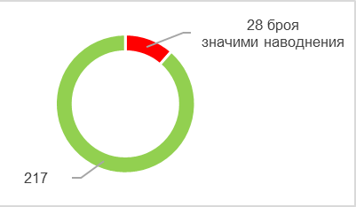  Total number of past floods, incl. significant ones |   Total number of locations, incl. such with significant adverse effects
More detailed information on all past floods, and in particular on those with significant adverse effects can be found in the diagrams below. They show the relative share of floods per location in relation to different types of flood sources, mechanisms and characteristics. Complex floods, i.e. with more than one source of origin, are also included in the analysis, whereby different types of floods may have occurred in one location. The total number of locations is therefor greater than the one shown on the previous chart.
According to their source, floods are classified into fluvial, pluvial, flooding from groundwater and infrastructure-related flooding. Below diagram indicates the number of floods in each category, whereby significant floods are marked red.

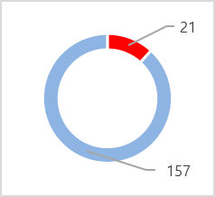  Fluvial flood | 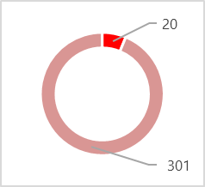  Pluvial flood |   Flooding from groundwater | 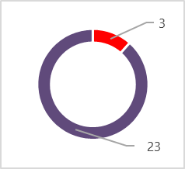  Infrastructure-related flooding
The distribution of past floods depending on their source per year is presented in the diagram below.
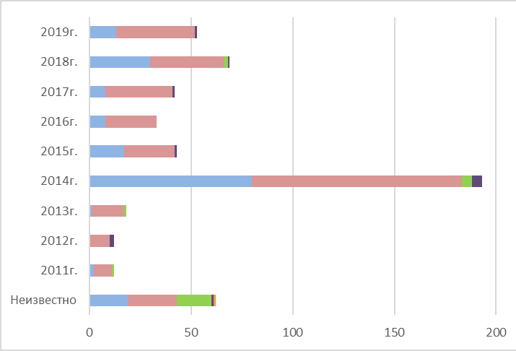
  Fluvial flood
  Pluvial flood
  Flooding from groundwater
  Infrastructure-related flooding
Given their occurrence mechanism, there are predominantly floods resulting from backwatering or reduced conductivity, as well as natural river overflow. This trend is also true with regard to significant floods.
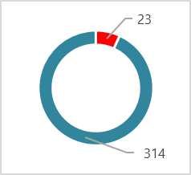  Backwatering or reduced/disrupted conductivity | 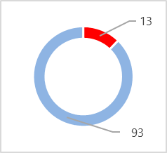  Natural river overflow | 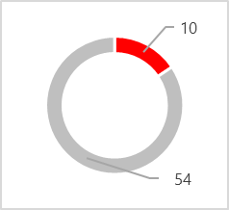  Overtopping of protective facilities | 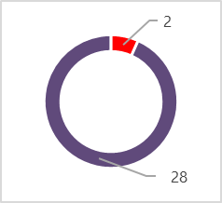  Protective or infrastructural system failure
In terms of their characteristics, torrential floods have the largest share. Significantly smaller shares are occupied by occurrences described as other flash floods, alluvial fan flooding, gradual flooding and high flow velocity, as well as floods with no information about their characteristics (51, 5 of which were significant).

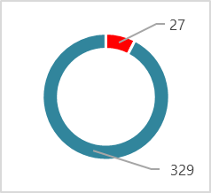  Torrential flooding | 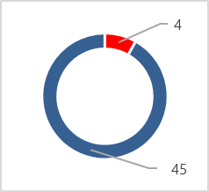  Other flash flooding | 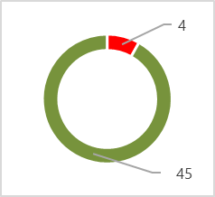  Alluvial fan flooding | 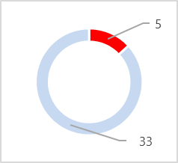  Gradual flooding
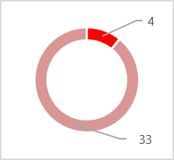  High flow velocity | 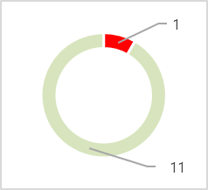  Slow flooding | 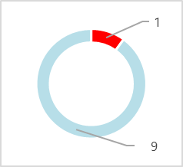  Snowmelt flooding |   Deep water flooding
After reviewing past floods and identifying those with significant adverse effects, an analysis of all unclassified occurrences was carried out as to whether they would lead to significant potential consequences, if they were to recur today or in the future (as per FD Art.4.2(c)). 255 floods have been analyzed in accordance with the 2020 PFRA Methodology requirements in terms of their locations. The analysis was facilitated by the database, prepared under the Methodology in MS Excel format with its respective functionalities, where parameters are automatically calculate after entering flood data. These parameters include: specifics of settlements (number of affected settlements and number of inhabitants), flood characteristics (size of flooded area, recurrence and duration). By entering data for each flood within the database, recurrence probability parameters are automatically calculated. In order to calculate risk elements in the floodplain, NSI population data from 2012 to 2019 were used to track changes. Master Plan and Cadaster data on current or planned land-use and infrastructure changes was also taken into account.
The analysis identified only 2 locations where risk indicators exceeded significance thresholds for number of inhabitants. Detailed follow-up analysis showed that the first instance concerns a population of less than 10 people, whereas in the second case the floodplain is outside the urban area, which is why the floods are assessed as insignificant.

- Future Floods
  - Results
After performing a comprehensive analysis in order to determine future floods under Art. 4.2(d), 20 floods in the Danube RBMD have been identified as potential significant future floods. They are of the following types - pluvial-torrential floods: 17; pluvial-urban floods: 3. They are presented as a schematic map below.
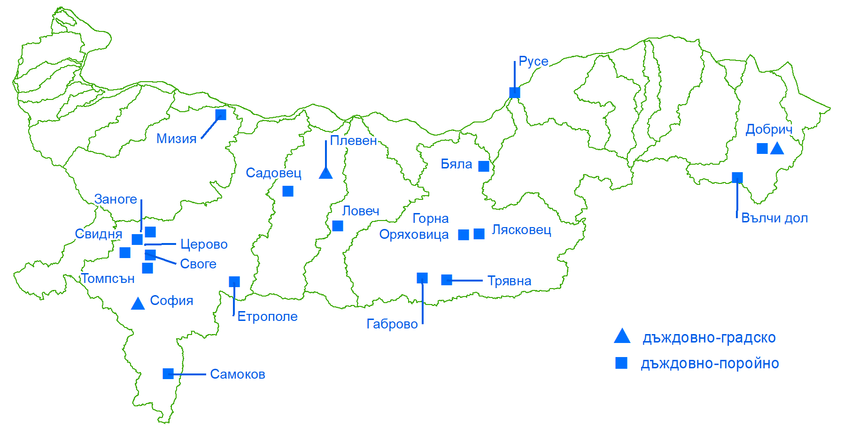
A risk assessment was carried out for each identified location per the main 4 categories: human health, economic activity, environment and cultural heritage and their respective sub-categories. Summarized results for all locations are presented in the following diagrams.

Human Health Category |  | Cultural Heritage Category
Human Health  | Society  | Cultural property
  high risk
  medium risk
  low risk
Economic Activity Category
Real estate | Infrastructure | Primary sector | Secondary sector
Environment Category
Water body status   |   Protected areas |   Pollution with hazardous substances |   Other adverse effects for the environment
- Facilities Impact Analysis
The current draft PFRA takes into account all available information at the time of assessment on hydrotechnical systems and facilities, facilities for protection against harmful effects of water and sewerage systems.
With regard to reservoirs, an analysis was carried out on the condition of complex and significant dams (WA, Appendix №1 under Art. 13(1)), hydro-melioration reservoirs under the stewardship of Irrigation Systems EAD of MAFF, as well as all other municipally-managed or leased reservoirs.
For facilities, where information was received that they are in faulty condition, on-site consultations were conducted and relevant facilities representing a threat have been identified based on received additional information.
- Identifying APSFRs
  - Identified APSFRs
As a result of the PFRA update, 35 APSFRs have been identified within the Danube RBMD, 8 of which are new. They are located in nine main river valleys. Their location and the number of river valleys are shown on the schematic map below.

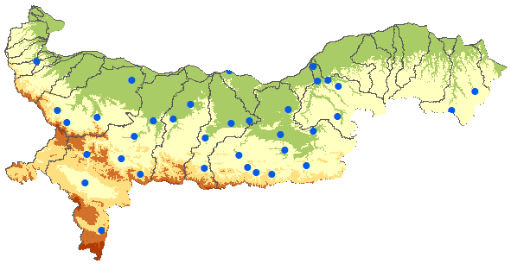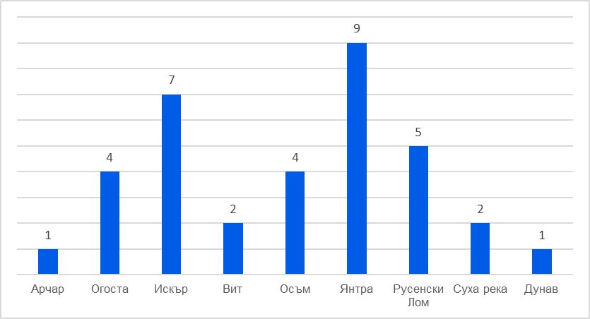

In each APSFR one or several different types of floods have been identified, for which flood hazard and risk maps shall be prepared within the next FD stages. There are a total of 4 types of floods: fluvial, pluvial-torrential, pluvial-urban and infrastructure-related. Infrastructure-related floods examine overtopping or dam failure hazards.
The location of APSFR per types of floods is presented in the schematic map below.

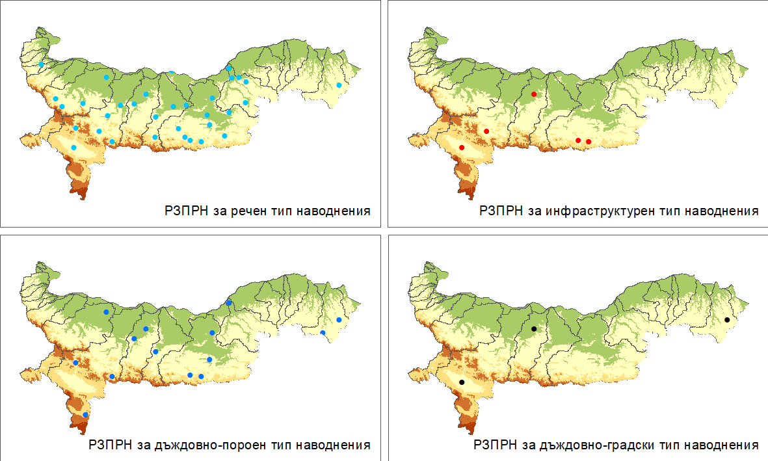

APSFR for the Danube river

Art. 146а. (1) requires carrying out a PFRA for each river basin management district, also for the Bulgarian part of the Danube river, which also includes defining APSFR as appropriate.
During the first FD implementation cycle, the Bulgarian section of the Danube river was identified as an APSFR (BG1_APSFR_DU_001). In coordination with competent authorities in Romania, the Bulgarian-Romanian section of the Danube River has been designated as a common international APSFR for Bulgaria and Romania, whereby a common designation code has been adopted (RO_BG_DU_1) in accordance with the policies of the International Commission for the Protection of the Danube River (ICPDR) in order to maintain and exchange information. FD implementation activities in this APSFR, incl. the subsequent preparation of flood hazard and risk maps and flood risk mitigation measure planning shall be carried out considering the transboundary nature of the area and through exchange of information with Romania and other ICPDR Member States.

LIST of identified APSFRs in the Danube RBMD
APSFR code | APSFR name | Type of flood according to source
BG1_APSFR_DB_100 | Dobrichka river - town of Dobrich | fluvial, pluvial-torrential  pluvial-urban (town of Dobrich)
BG1_APSFR_DB_101 | Arabadzhidere river - town of Valchi Dol | pluvial-torrential
BG1_APSFR_IS_011 | Iskar river - town of Roman | fluvial
BG1_APSFR_IS_031 | Bebresh river - village of Skravena | fluvial,  infrastructure-related (overtopping of Babresh dam)
BG1_APSFR_IS_033 | Iskar river - from village of Vlado Trichkov to village of Zverino | fluvial  pluvial-torrential
BG1_APSFR_IS_041 | Iskar river - city of Sofia (Sofia Valley) | fluvial  pluvial-urban (city of Sofia)  infrastructure-related (overtopping of Pancherevo dam and dam failure of Mramor and Maslovo reservoirs)
BG1_APSFR_IS_100 | Iskar river - town of Cherven Bryag | fluvial
BG1_APSFR_IS_101 | Bokludzha river - town of Samokov | pluvial-torrential
BG1_APSFR_IS_102 | Malak Iskar river - town of Etropole | fluvial, pluvial-torrential
BG1_APSFR_OG_012 | Varteshnitsa river - from village of Beli Izvor to village of Vlasatitsa | fluvial
BG1_APSFR_OG_061 | Berkovska river - town of Berkovitsa | fluvial
BG1_APSFR_OG_100 | Skat river - from town of Byala Slatina to town of Miziya | fluvial, pluvial-torrential
BG1_APSFR_OG_101 | Dalgodelska river - from village of Dalgi Del to village of Gavril Genovo | fluvial
BG1_APSFR_OS_011 | Osam river - town of Letnitsa | fluvial
BG1_APSFR_OS_012 | Lomya river - village of Butovo | fluvial
BG1_APSFR_OS_021 | Osam river - town of Lovech | fluvial, pluvial-torrential
BG1_APSFR_OS_031 | Osam river - town of Troyan | fluvial
BG1_APSFR_RL_011 | Cherni Lom river - from village of Aprilovo to village of Kardam; Popovski Lom river - town of Popovo | fluvial
BG1_APSFR_RL_014 | Rusenski Lom river - from village of Bozhichen to town of Ruse | fluvial, pluvial-torrential
BG1_APSFR_RL_100 | Cherni Lom river - from village of Tabachka to village of Koshov | fluvial
BG1_APSFR_RL_101 | Beli Lom river - from village of Pisanets to village of Nisovo | fluvial
BG1_APSFR_RL_102 | Dolapdere river - town of Tsar Kaloyan | fluvial
BG1_APSFR_VT_011 | Vit river - town of Pleven | fluvial, pluvial-torrential  pluvial-urban (town of Pleven),  infrastructure-related (overtopping of Totlebenov Val and Kaylaka dams and dam failure of Dolna Mitropoliya reservoir)
BG1_APSFR_VT_100 | Barata river - village of Sadovets | fluvial, pluvial-torrential
BG1_APSFR_WO_051 | Archar river - town of Dimovo | fluvial
BG1_APSFR_YN_011 | Yantra river - from village of Radanovo to village of Starmen | fluvial, pluvial-torrential
BG1_APSFR_YN_021 | Rositsa river - from village of Vodoley to village of Resen | fluvial
BG1_APSFR_YN_022 | Golyama Reka river - town of Strazhitsa | fluvial
BG1_APSFR_YN_023 | Yantra river - from village of Lednik to town of Dolna Oryahovitsa; Belitsa river - from village of Natsovtsi to town of Debelets | fluvial  pluvial-torrential
BG1_APSFR_YN_031 | Yantra river - town of Gabrovo | fluvial, pluvial-torrential  infrastructure-related (dam failure of Hristo Smirnenski reservoir)
BG1_APSFR_YN_041 | Rositsa river - town of Sevlievo | fluvial
BG1_APSFR_YN_061 | Elenska river - town of Elena | fluvial
BG1_APSFR_YN_100 | Tributary of Lopushnitsa river - village of Vranilovtsi | fluvial
BG1_APSFR_YN_101 | Dryanovska river - from town of Plachkovtsi to town of Tryavna | fluvial, pluvial-torrential  infrastructure-related (dam failure of Tryavna - Ezeroto reservoir)
BG1_APSFR_DU_001 | Danube river | fluvial
  - APSFR Documentation
Detailed documentation has been created for all identified APSFRs. It includes the following enclosures.

- Informing the Public and Consultations
In preparation for the PFRA update, stakeholders were consulted due to an established lack of information on past floods that occurred in the country in the period 2011 - 2019. These consultations were conducted in two stages:
- Questionnaire survey;
- A series of workshops.
The purpose of the survey was to gather detailed information about past floods in the period 2011 - 2019 for the entire RBMD.
After receiving completed questionnaires, the information provided therein was processed, systematized and entered into a common database.
Representatives of 160 institutions and organizations, i.e. 70% of all respondents, participated in the survey and workshops. The diagram shows the number of participating institutions in relation to the total number of respondents.
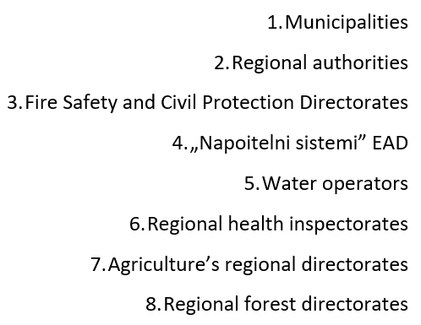
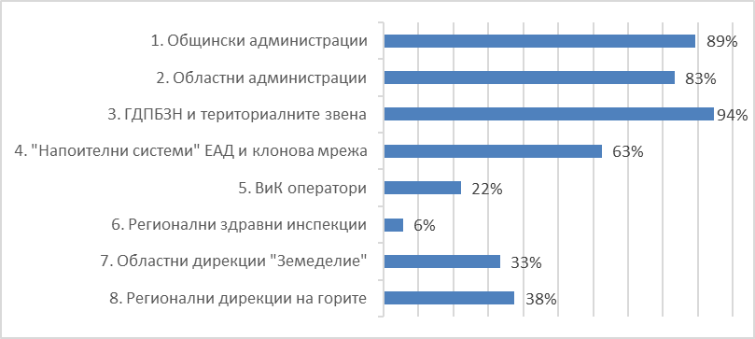
In order to refine and supplement the data, 6 workshops were held in different cities - Sofia, Montana, Pleven and Ruse.

- Next Steps

PFRA and identifying APSFRs is the first stage of preparing FRMPs under the FD. The next steps in this process are:
- Mapping flood hazard areas and flood risk maps - FD Chapter III, WA Section III;
- Updating the Flood Risk Management Plan (FRMP) - DF Chapter IV, WA Section IV.

